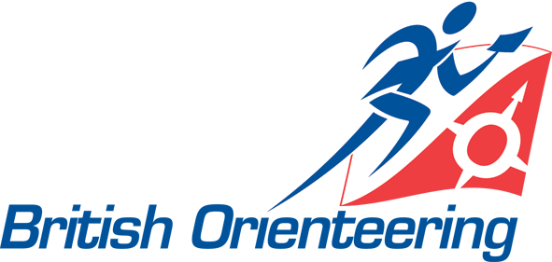
Event and Competitons Committee
Supporting Workgroups
Application Form

Please complete sections A-E, sign the declaration and return to British Orienteering National Office, Molyneux Business Park, 8a Stancliffe House, Whitworth Road, Darley Dale, Matlock, DE4 3EA or by e-mail to HErrignton@britishorienteering.org.uk

If you require any assistance to complete this application form, please call Janine White on 01629 734042 or email jwhite@britishorienteering.org.uk

Please note the closing date for applications is 12.00pm on Monday 24th September 2012

Section A
Surname |  | Address
First name
British Orienteering Membership Number (if applicable).
Telephone (day)
Telephone (evening) |  | Post Code
Email

Section B
Ethnicity | I would describe my ethnicity as:
Gender (please indicate) | Male ☐ | Female ☐
Disability | Do you consider yourself to have a disability? If yes, please state below
Convictions | Do you have any criminal convictions/convictions pending? If yes, please provide details below:

Please select the workgroup(s) and /or specialist group(s) on which you would be interested in serving. If applying for Event Officials, Event Systems or Event Programme and Publicity groups, please also tick if you would be willing to Chair those groups and/or their specialist groups subgroups.

Section C
☐Event Officials Group | ☐Event Systems Group | ☐Event Programme and Publicity Group | ☐Map Advisory Group | ☐Technology Advisory Group
☐Chair of Event Officials Group | ☐Chair of Event Systems Group | ☐Chair of Event Programme & Publicity Group
 | ☐Chair of Technology Advisory Group

Please give details of your skills, experience and knowledge to demonstrate how you meet the requirements of the workgroups indicated in section C. Please enclose additional sheets with any further information you may wish to give in support of your application.

Section D

Section E- Code of Conduct
Events & Competitions Committee

Code of Conduct for Committee & Group Members

I, as an applicant for membership of Events & Competitions Committee or its supporting workgroups, agree to:

- Make informed decisions on a variety of matters using my relevant knowledge and experience of orienteering and of British Orienteering.

- Be committed to the vision and aims of British Orienteering and the delivery of the strategic plan for the development of orienteering.

- Be objective and place personal views aside.

- Form and maintain good working relationships within and outside the group.

- Be able to work toward consensus and accept ‘cabinet’ decision.

- Understand the role of the group and its relationship with the Board and Senior Management team of British Orienteering.

- Have a personal awareness of the ethics and integrity required to serve on a national committee.

- Be available to attend one or two meeting(s) per year on Saturdays (dates agreed in advance), and the induction session and any training days as agreed with the Chair.

- Be able and willing to communicate between meetings using email or conference call; group members should normally be able to respond to email communications within 48 hours.

Name: Date:

Declaration
I declare that, to the best of my knowledge, the information contained in this form is true and accurate.

Signature |  | Date

